**Guidelines**

* Use Visual Studio & SQL server express to do development.
* Use this opportunity to demonstrate your all-round design and coding skills
* Additional Credit will be given for
* Make application more configurable. Example: Location of file, Column names etc.
* Innovative design
* Unit Tests
* Use of SOLID Design Principle
* Once Completed, please zip up your solution folder code and email it back
* Date is in dd/mm/yyyy format.

**Excel Data Loader Test**

Write console programme which reads attached excel file and store in SQL server database table.

Column Names in Excel:

* Commodity Code
* Diminishing Balance Contract
* Expiry Month Limit
* All Month Limit
* Any One Month Limit
* Valid From (dd/mm/yyyy)

**Data Reader**

Read and display data from newly created SQL table as part of Excel Data Loader Test based on Valid From and commodity code columns filters.

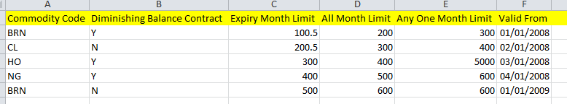

Scenarios:

When user inputs Valid From Date to 02/01/2018 and commodity as BRN then it should return



When user inputs Valid From Date to 02/01/2010 and commodity as BRN then it should return



When user inputs Valid From Date to 01/01/2007 and commodity as BRN then it shouldn’t return anything.